Android Setup

1. Go to official Android website (<https://developer.android.com/studio>) and Download Latest Version of Android Studio.

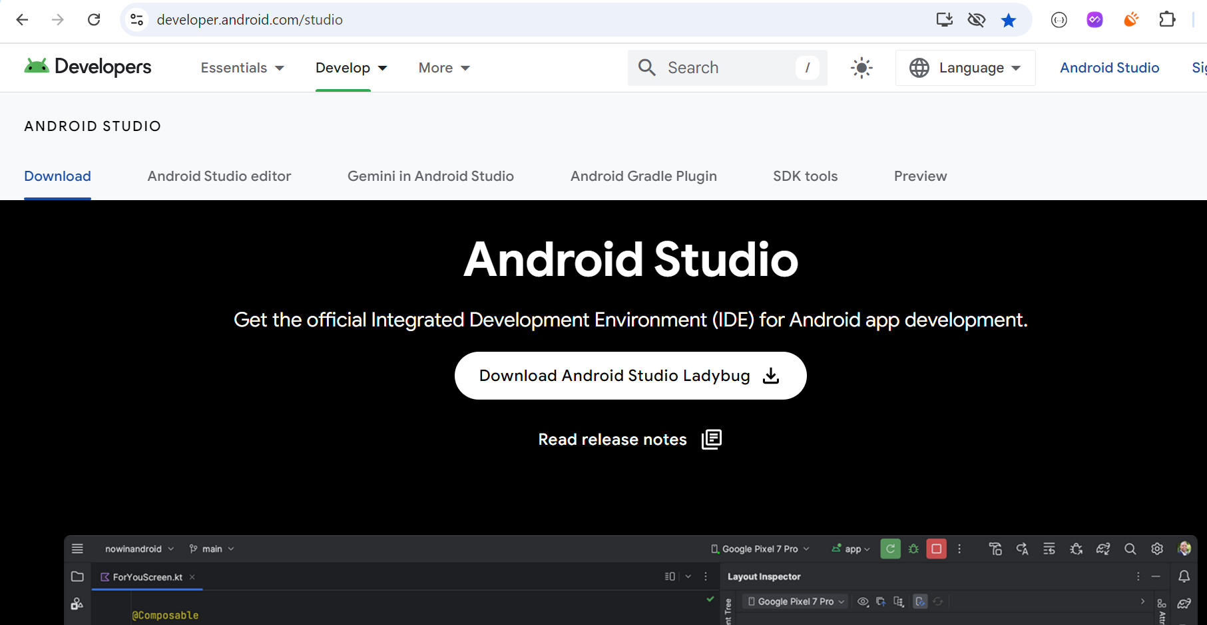

1. Click on .exe file.

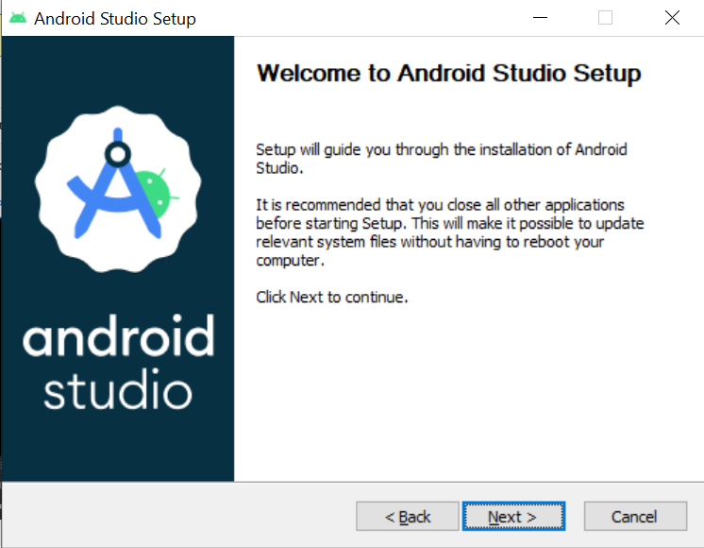

And click on next button.

1. Check both components to install and click on next button.

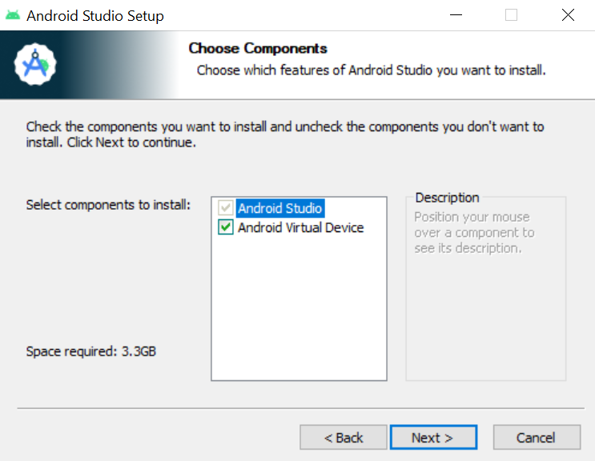

1. Set a path of Android studio installation and click on next button.

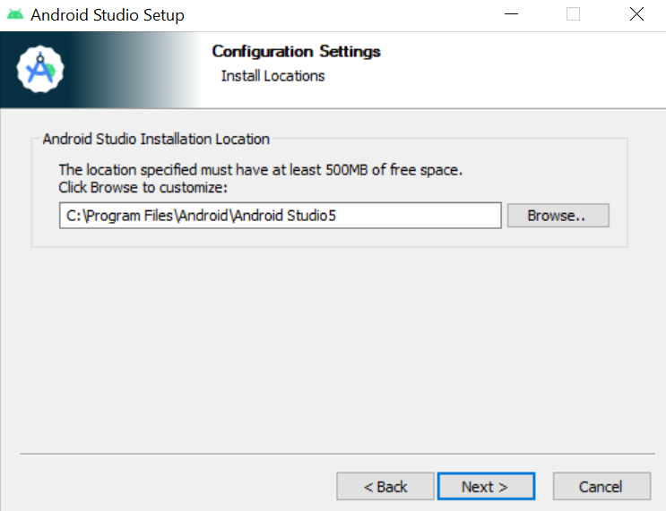

1. Choose Start menu Folder : Android Studio and click on Install button so installation will be start and after complete open android studio.

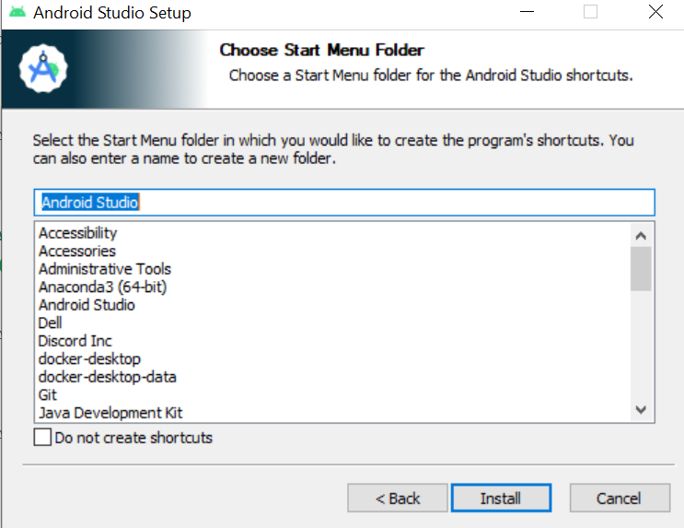

1. Opne Android Studio and click on New Project Button.

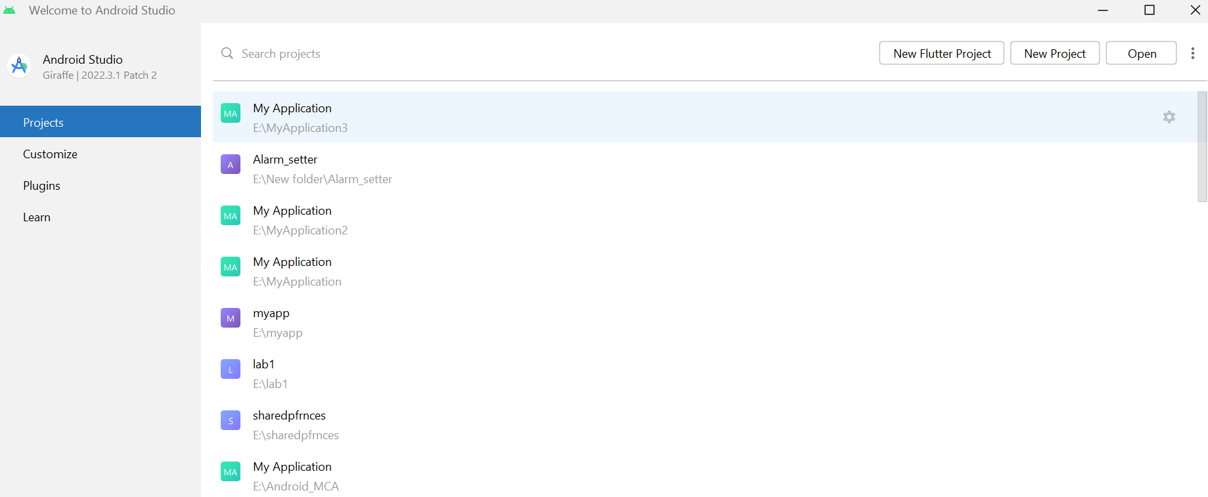

1. Select Empty views Activity and click on next Button.

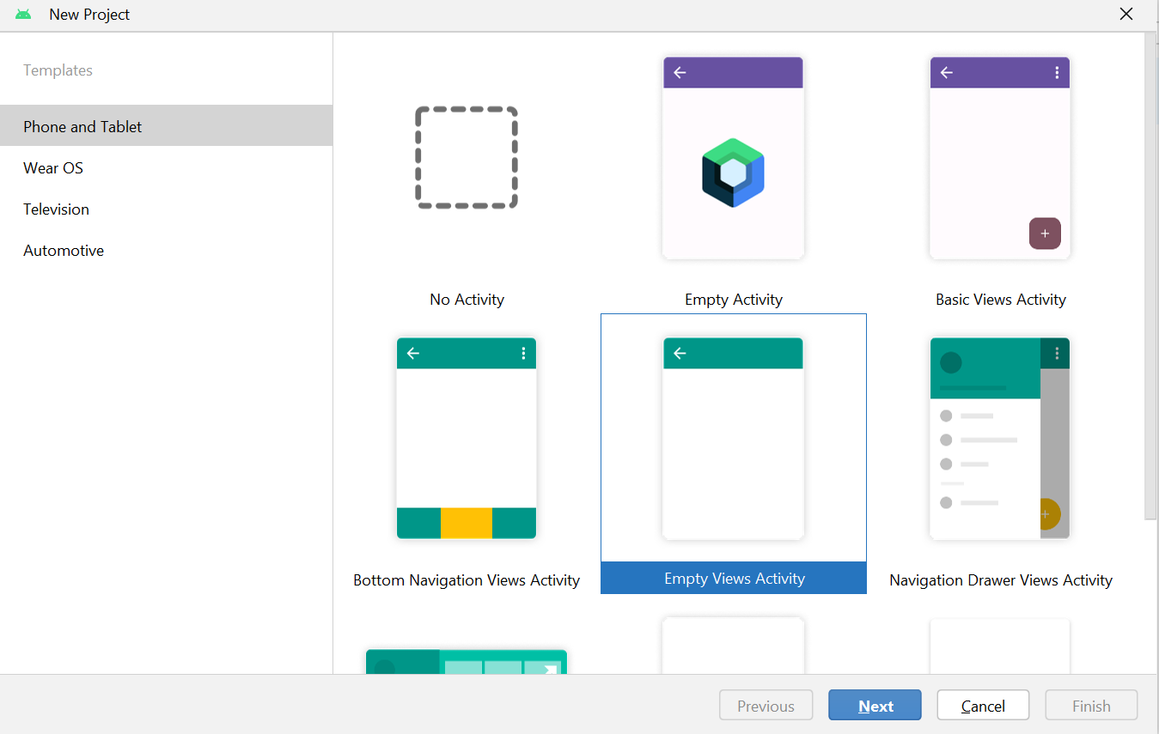

1. Give project name, path, package name, Language – select java and click on finish button to create project.

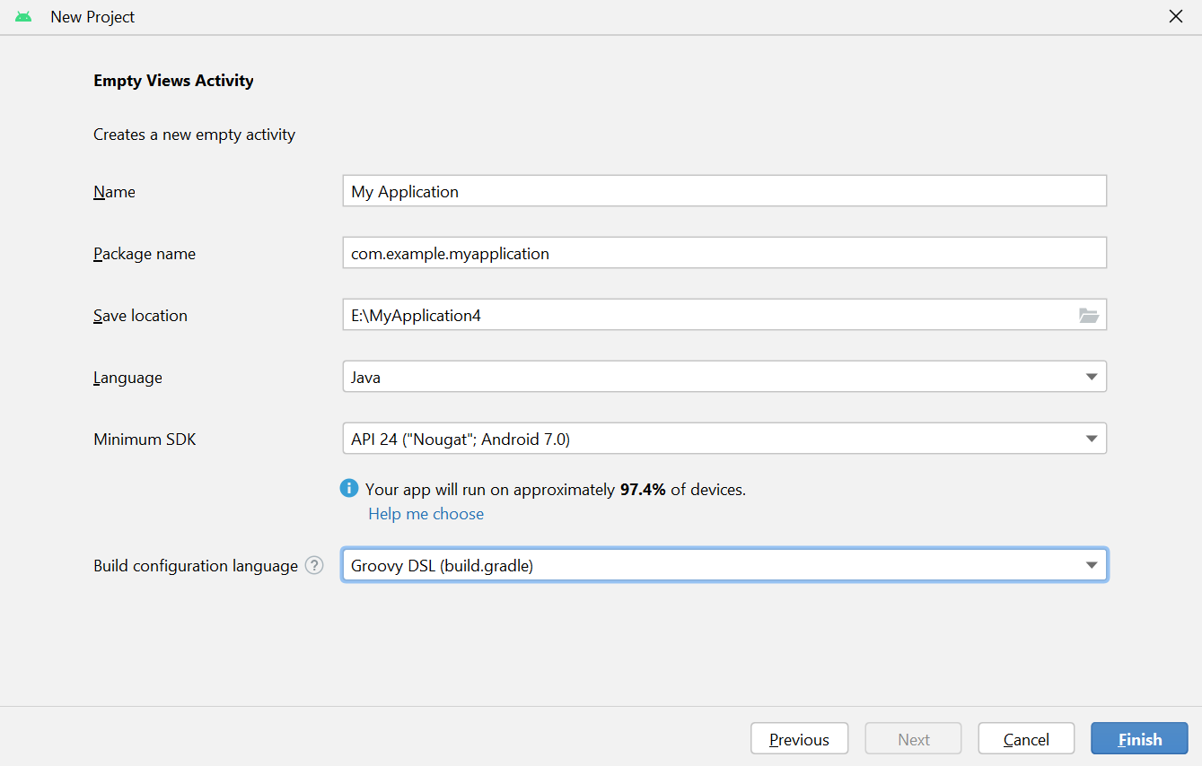

1. Project create successfully.

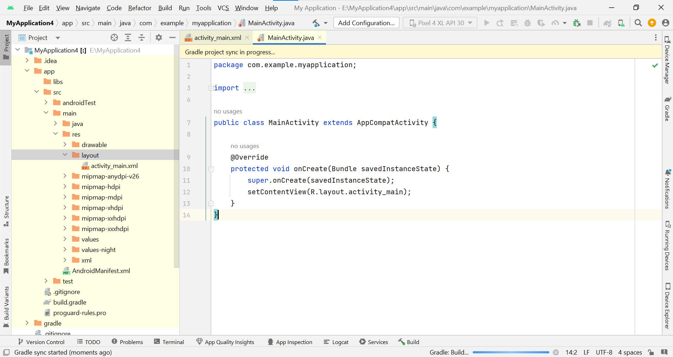

Flutter Setup

1. Go to Flutter official website (https://docs.flutter.dev/get-started/install) for install Flutter SDK and select window.

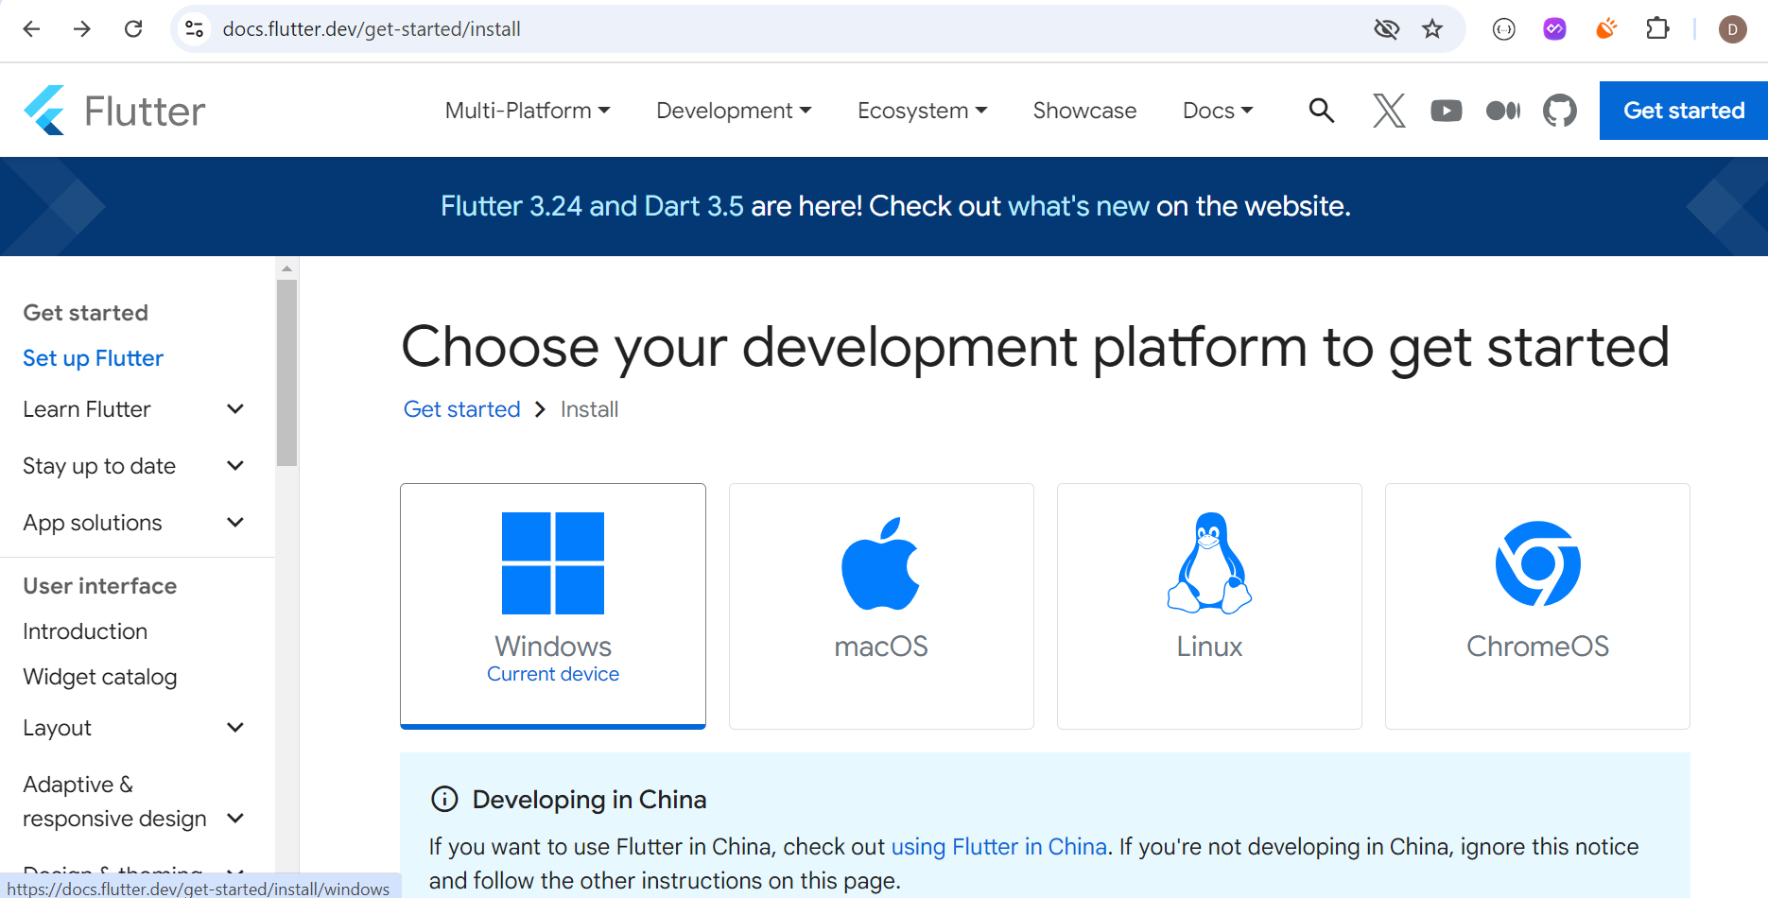

1. Select type of app : Android

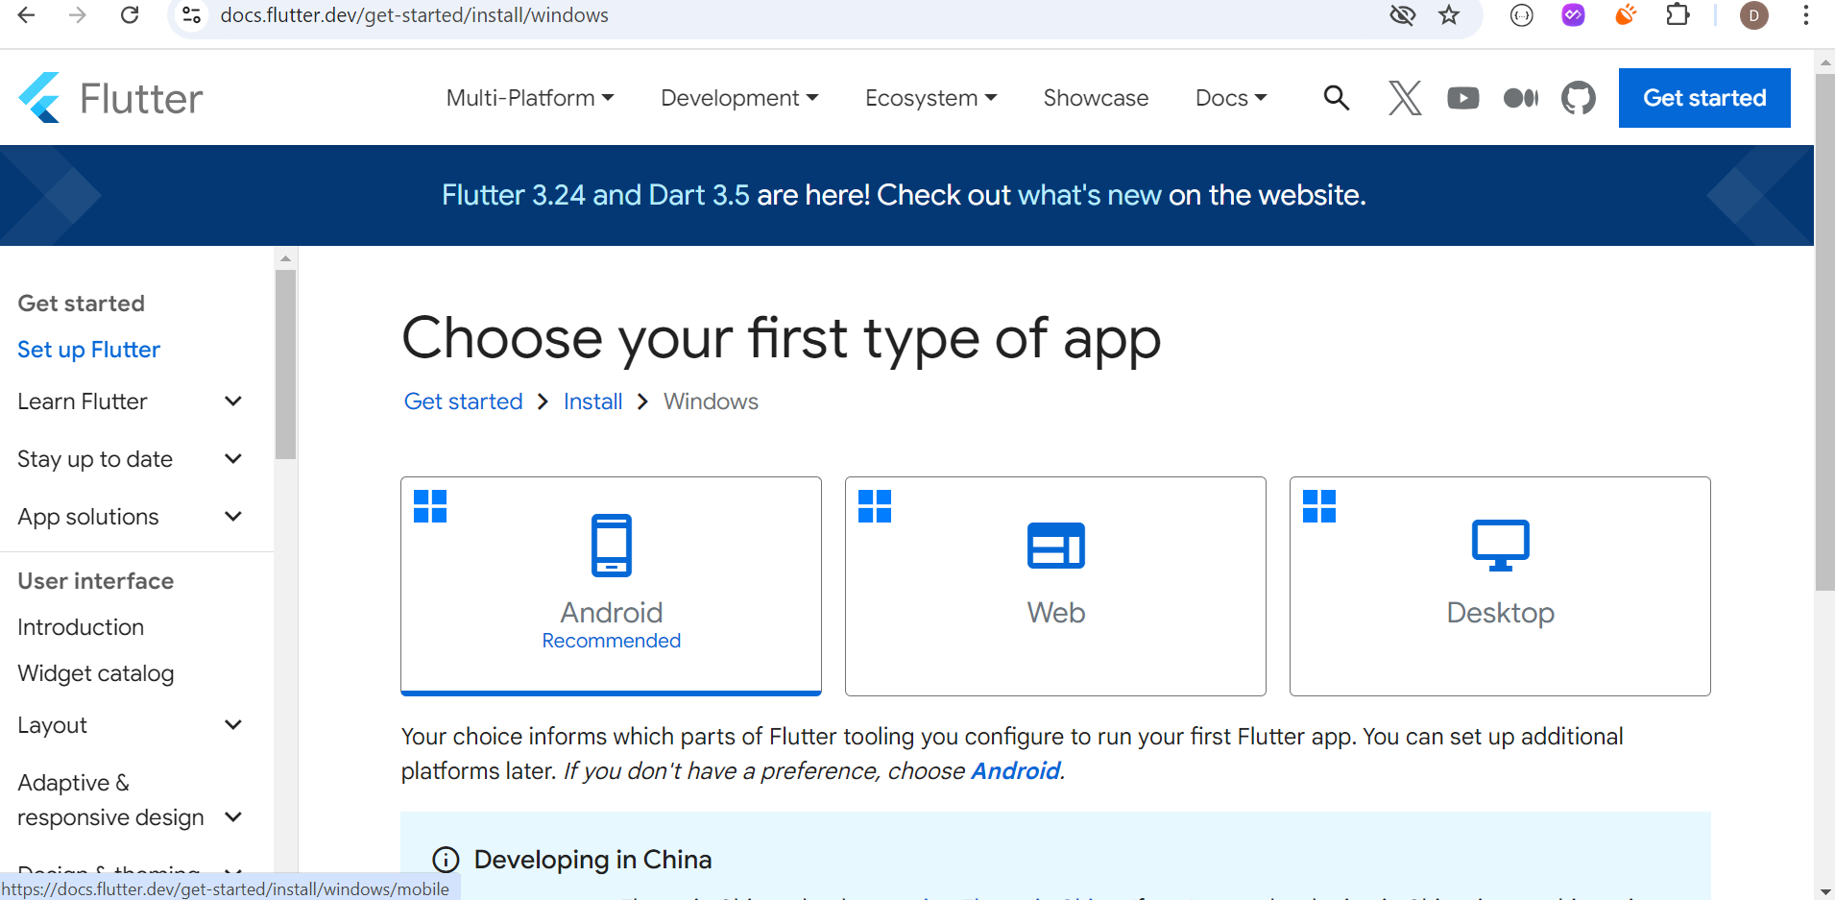

1. Download the stable zip file.

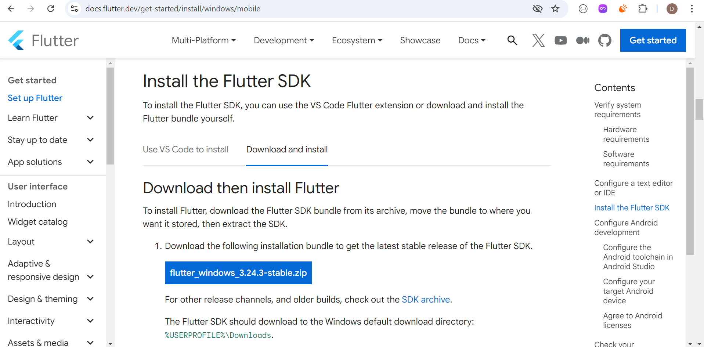

1. Zip file will be extract in any specific drive in pc.

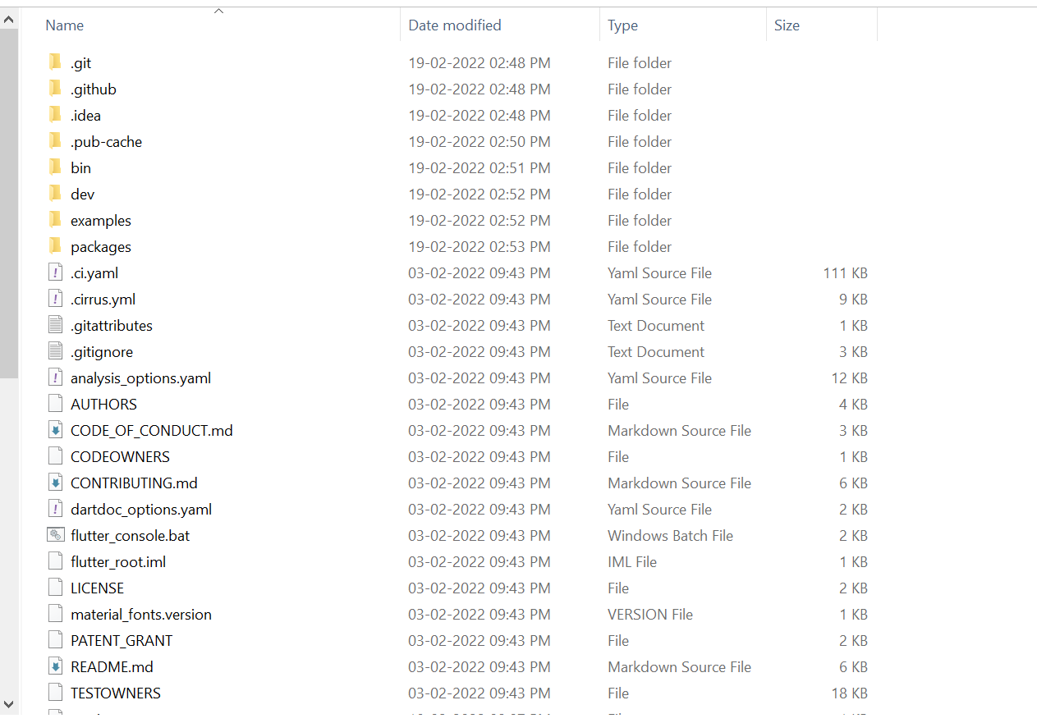

1. Set it’s bin path in environment variable in PC and check it’s set properly or not,

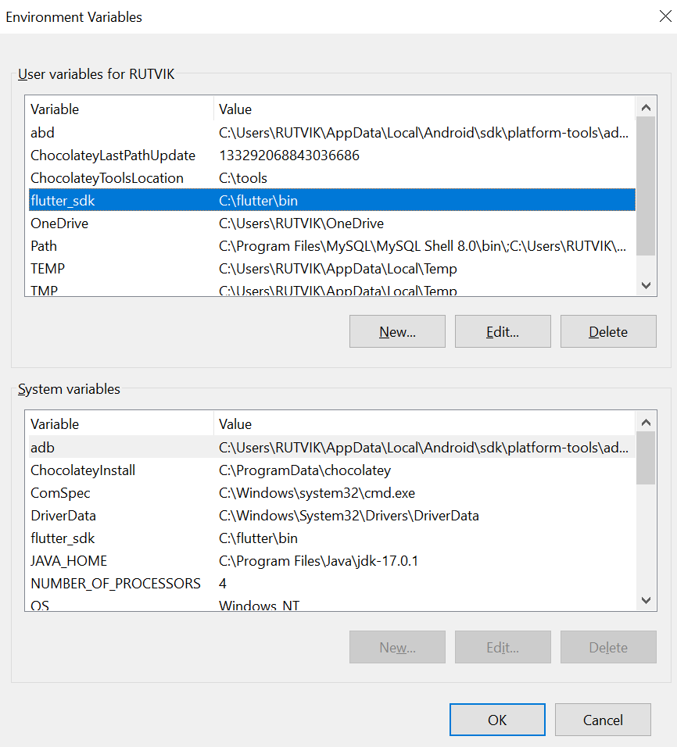

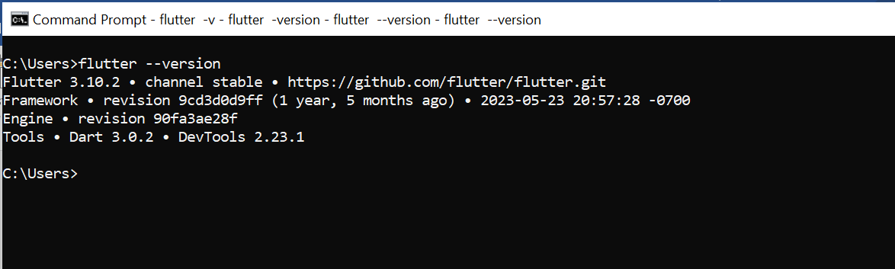

1. Go to Android Studio and install Flutter Plugin after installation restart your android Studio.

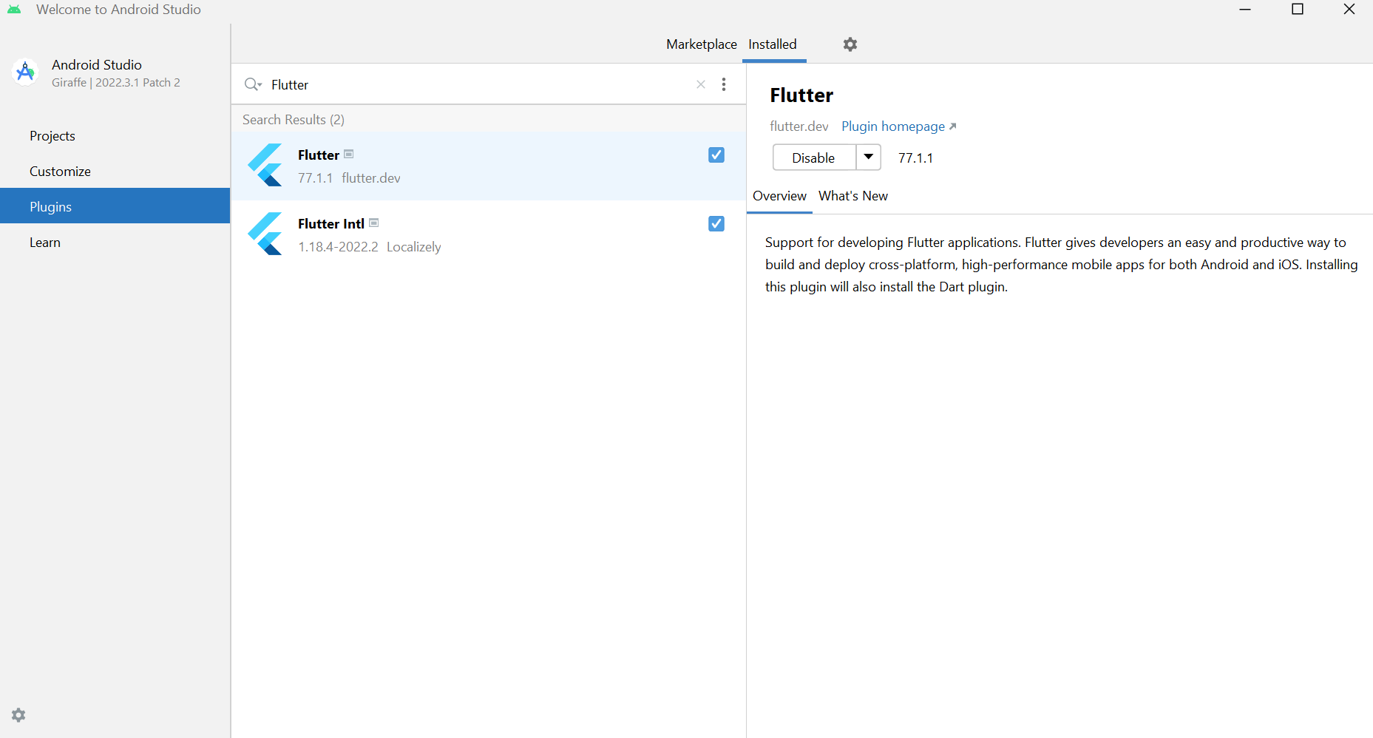

1. Click on new Flutter Project for flutter project creation.

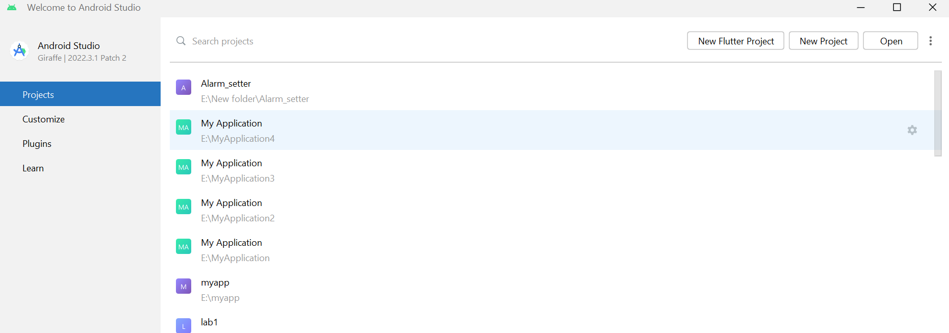

1. Set Flutter SDK Path.

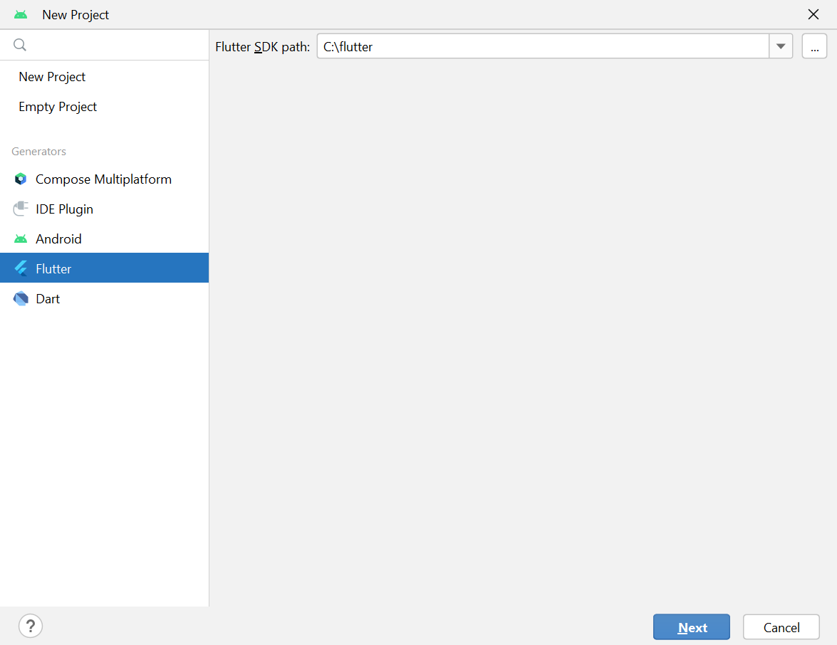

1. Give project name, path, Desc., select platforms, language etc.. and click on create button.

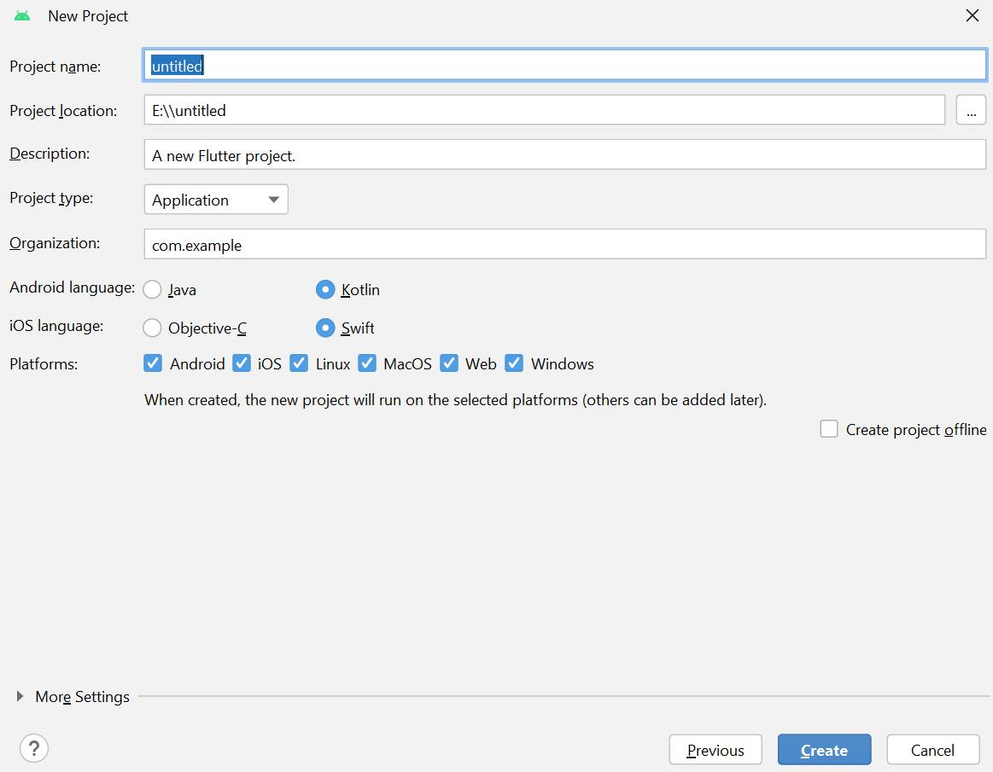

Project Create Successfully.

